**Administration tasks:**

To create users, go to subversion_dir/apache2/bin and use the below command to create the user

* ./htpasswd -m <DIR/file name> <username> 🡪 it will ask for the password when we run this command

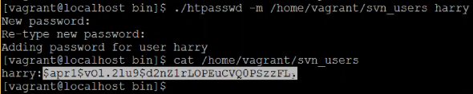

The file name is which we can use for storing the users. We need to create the file first and then we can check for the users in file as above

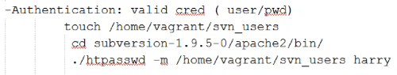

**Authorization:**

* And then for authorization also, we need to create another file which contains apache property file syntax to restrict the users
* It is divided into two parts. One is groups and another is repository
* There are three types of access on SVN as below

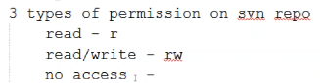

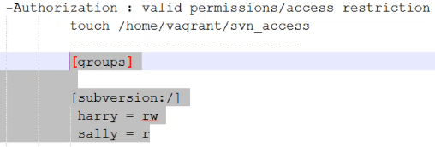

* We can use as above syntax in authorization file
* Now we need to integrate authentication and authorization files with apache/conf/httpd.conf
* So, go to subversion_dir/apache2/conf and edit httpd.conf file
* At the bottom of file, add the below lines with the paths of authentication and authorization files

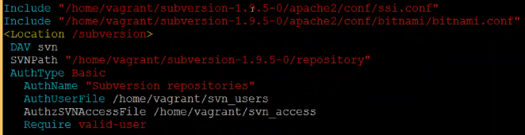

And then restart the server as below

* **./ctlscript.sh restart apache**

Now, every time we connect to the browser or we checkout or commit the code, it will ask for the authentication

Checkout along with the password, can be done as below

* **svn checkout <URL> --username**

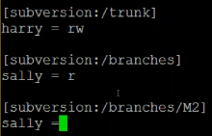

* We can give the syntax as above if we want to give permission to only trunk or branches
* If we have many users, instead of giving everyone separate access, we can create groups as below

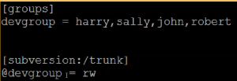

* If it is a group that we are giving access, then we need to use ‘@’ symbol as above
* Inside the svn directory, it stores the data in repository folder. If we want to create another directory, then create one and add it in apache2/conf/httpd.conf file as below

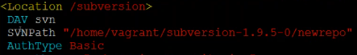

* If we want multiple repositories, then we can add another location syntax as below. But the names should different

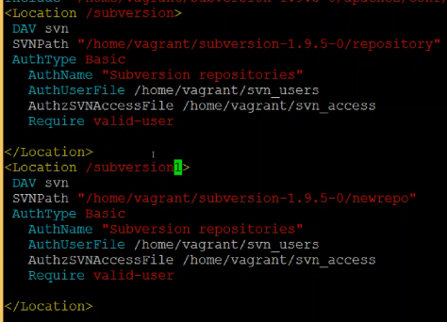

* After adding this, restart the server again

**Backup:**

* To take the svn backup, we can use the below command inside svn directory

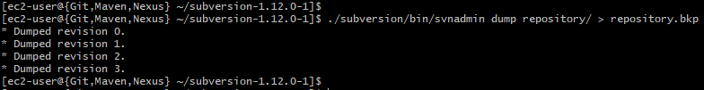

* It is better to keep bkp files in other server or other location

**Rollback:**

* Below are the steps to restore the SVN backup

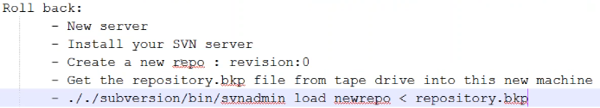



We can also take the range of revision numbers backup. We can get all the commands with help

* **./subversion/bin/svnadmin help dump**

**Hooks:**

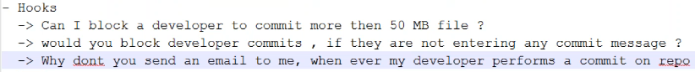

With the hooks, we can restrict the user

There are two types of hooks. They reside on repository

1. Pre commit
2. Post commit

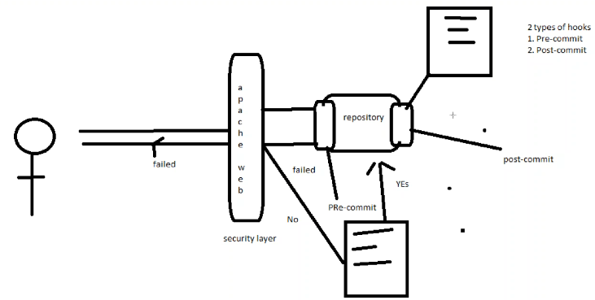

We will write a script file for these

For the third step as above image, we need to write it on post commit script

Inside repository, there will be a folder called hooks, and inside that we can find pre and post commit files

Remove the .tmpl at the end of file

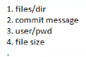

As per the above example metadata can be read with svnlook command

To see those command we can use below command inside svn directory

* ./subversion/bin/svnlook help

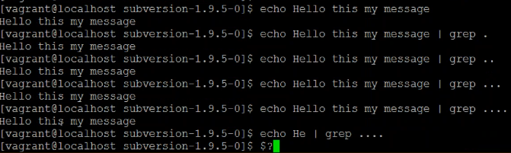

As above, ‘.’ Means the characters. If the message matches to . then it will display the message. Otherwise it won’t

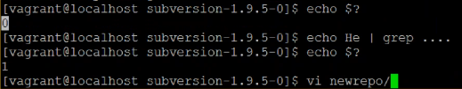

$? Is used to see the response of previous command

If the response is 0 then the command is successful, otherwise it is failed as above

Now we can clear all the data in pre commit file and write the script as above

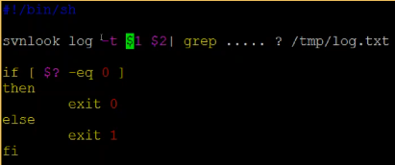

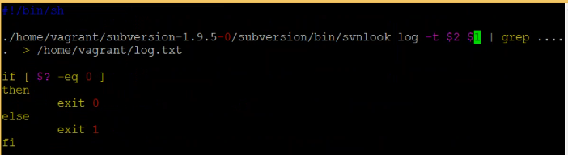

$1 and $2 are the two parameters will be passed at runtime at the time on svn commit

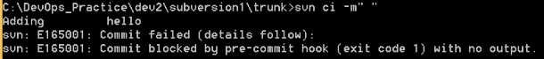

Now we can see it won’t allow to commit less than 5 characters of commit message

Like this we can add hooks to restrict the user